Lesson 2 Food Culture

TASK 1 What is the main theme?
本文の主題（メインテーマ）を句もしくは英文の形で書いてみよう。

TASK 2 Which graphic organizer is the most appropriate?
本文を１度読み、本文の構造に最も相応しいタイプのグラフィックオーガナイザーを選んでみよう。

出典：Power On EnglishⅠ Lesson２ （東京書籍）
①Problem–solution | 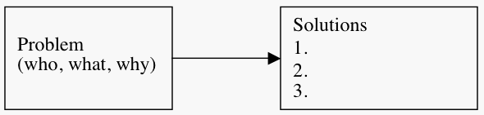
②Argument | 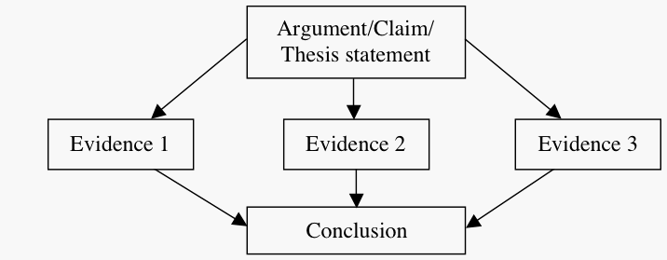
③For–against | 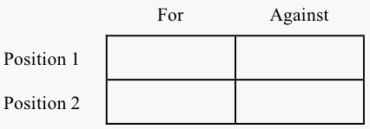
④Description and Classification |  | 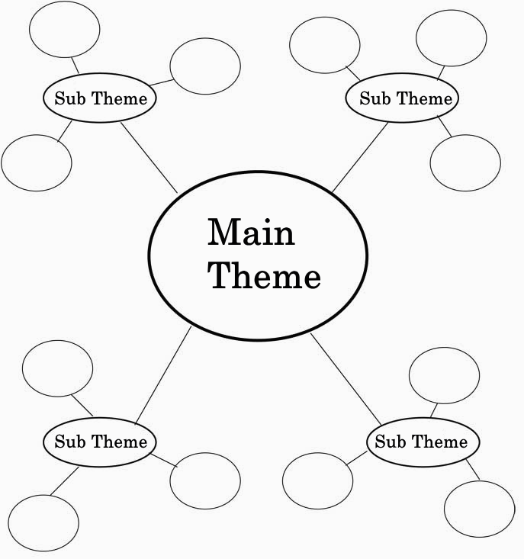
⑤Timeline | 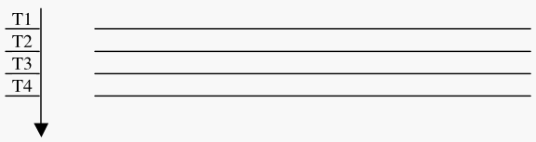
Lesson 2 Food Culture

TASK 3 What are the sub themes? Let’s listen to the text !
本文を聴いて、副題（各パラグラフの主題）を句もしくは英文の形で書いてみよう。

Main Theme
Sub Theme

Sub Theme

Sub Theme

TASK 4 Complete the graphic organizer. Let’s read the text !
本文を読んで、項目を書きくわえ、グラフィックオーガナイザーを完成させよう。

Sub Theme
Sub Theme

Main Theme

Sub Theme

出典：Power On EnglishⅠ Lesson２ （東京書籍）
【解答例】
 | keep  food good |  |  |  | cows
 |  |  | kill  bacteria |  |  |  | they give a lot of milk  in spring
food went
bad quickly
 | soy sauce  and wasabi |  |  | Cheese
they don’t give a lot of milk
in winter
Japanese
dishes
 | long  history |  | Food Cultures  Food Preservation
delicious |  |  |  |  |  | preserve  milk
Food cultures have something to do with the climate.
 |  |  | Spices |  |  |  | Indian curry
 | spicier than those in cold climates. |  |  |  | hot climates

参考文献：
Grabe, W. (2009). Reading in a second language: Moving from theory to practice. New York, NY: Cambridge University Press.

